CS 255 System Design Document Template

This template lays out all the different sections that you need to complete for Project Two. Each section has guidance to prompt your thinking. You will need to continually reference the interview transcript as you work to make sure that you are addressing your client’s needs. There is no required length for the final document. Instead the goal is to complete each section based on what your client’s needs are. Remove this note when you are finished, and replace all bracketed text with the relevant information.

UML Diagrams

UML Use Case Diagram

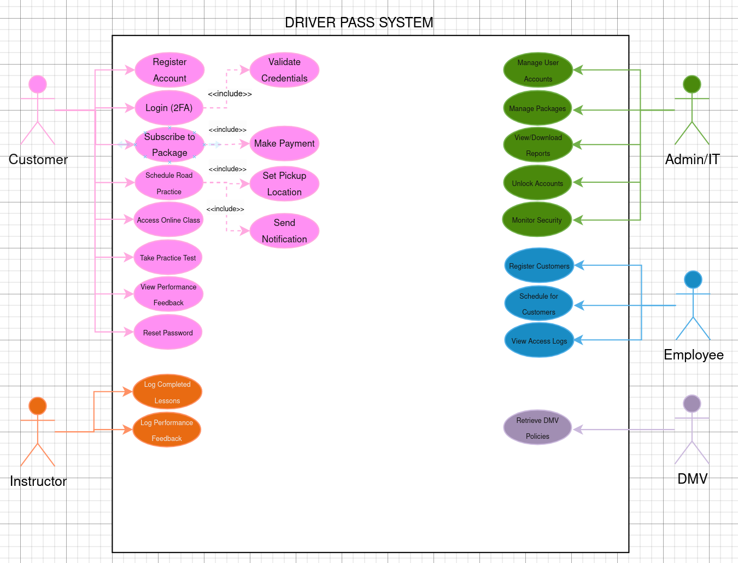

UML Activity Diagrams
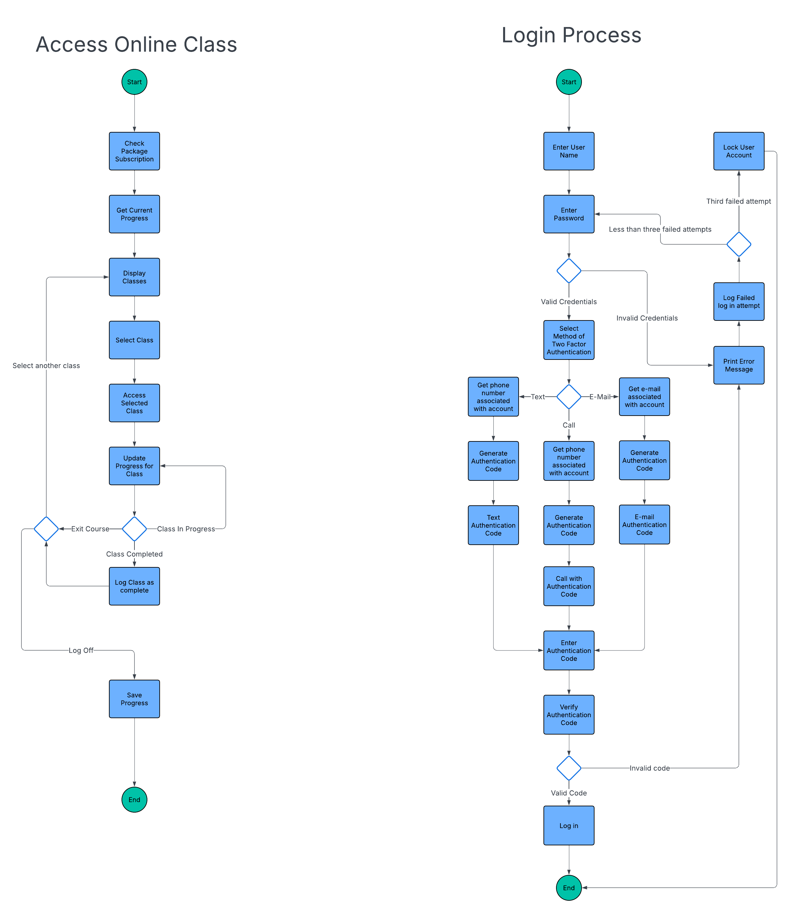

UML Sequence Diagram
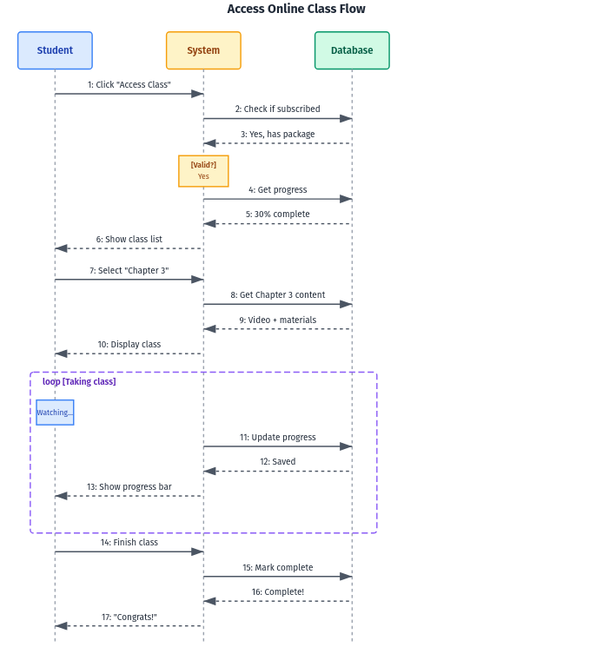

UML Class Diagram
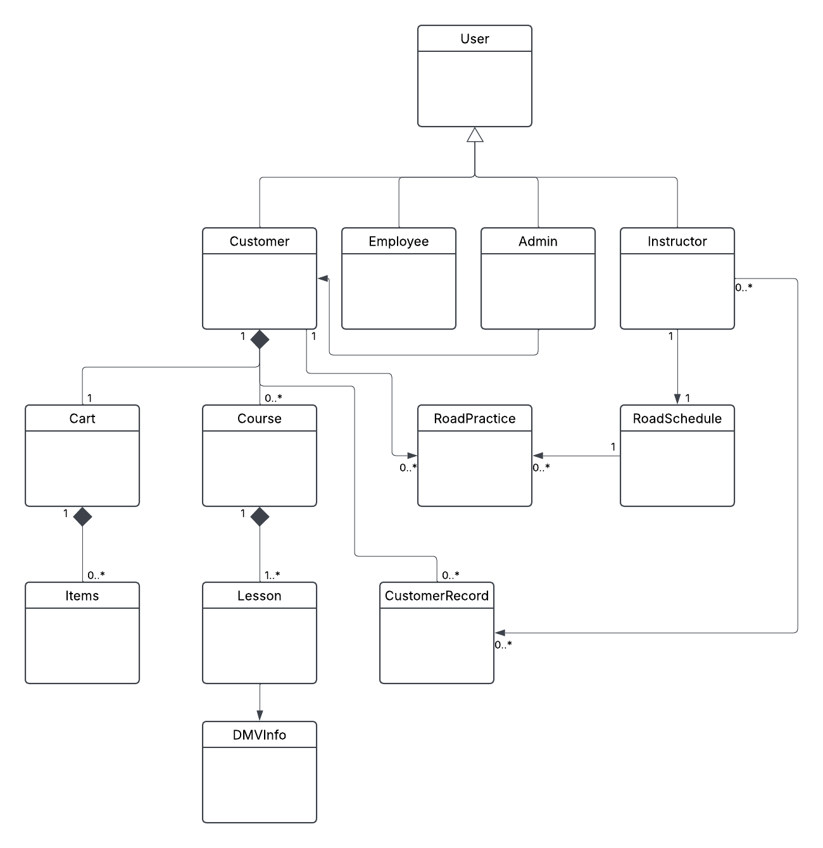

Technical Requirements
Necessary technical items include a database to store customer information as well as the courses and course information. On top of that, we would need a server to be able to host the web service, and another server to host the database. We will need a pay portal function, which I recommend finding a tool online for that in order to ensure that we have secure payment functionalities. As far as software is concerned, we will need to develop the web app for both desktop and mobile. From there we would also need to include a way to schedule rides, and select pickup locations. Additionally, we need an API for the DMV systems to get frequent, up to date data on rules and regulations.

